Kenneth Miralles Mora – Badges - Credly Link

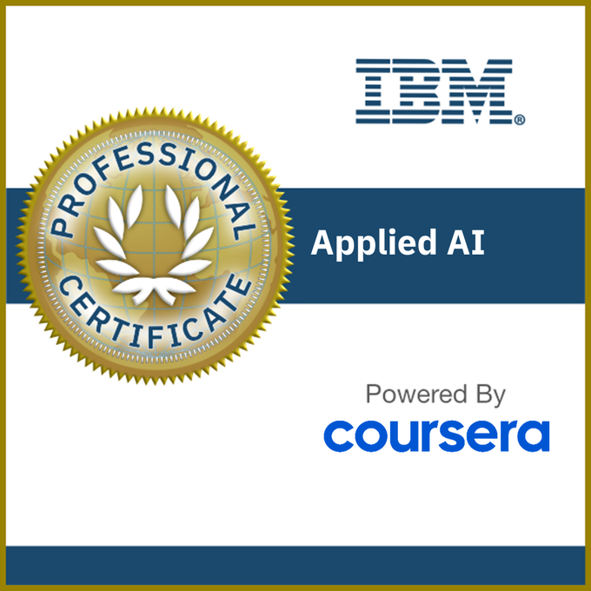
Earning Criteria
- Complete all courses in the IBM Applied AI Professional Certificate program on Coursera (includes quizzes, hands-on assignments and projects), and earn the following badges:
- - Introduction to Artificial Intelligence (AI)
- - Getting Started with AI using IBM Watson
- - Chatbot Building Essentials
- - Python for Data Science and AI
- - Building AI Applications with Watson APIs
- - Introduction to Computer Vision with Watson and OpenCV

